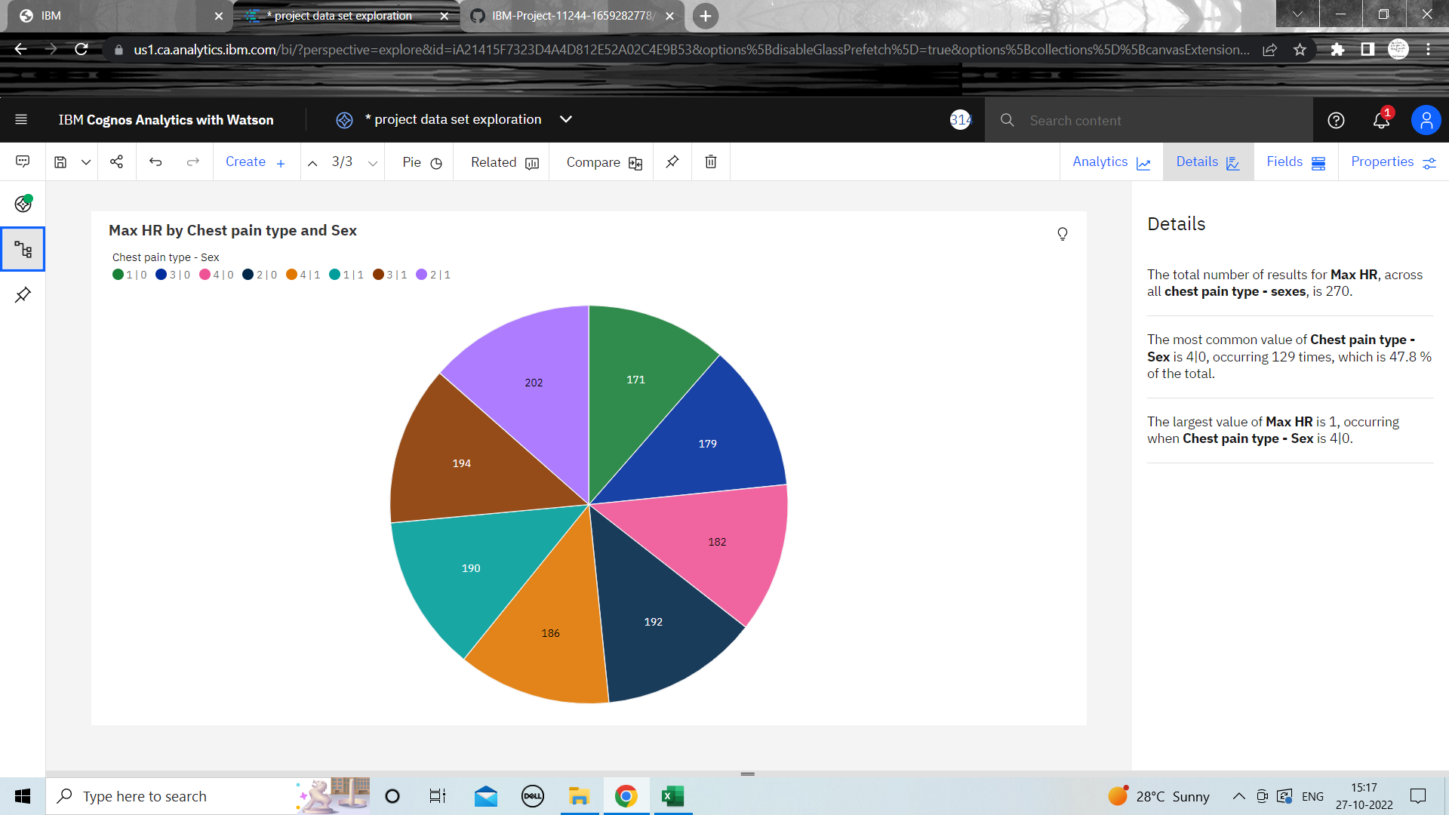**Exploration of MaxHR vs Chest pain type and Gender**